1. Adding records in Customers Table through Procedure 1(AddCustomer) using IN Parameter.

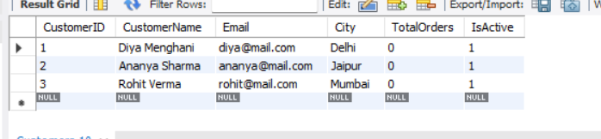

1. Updating Customer City in Customers Table through Procedure 2 (UpdateCustomerCity).

-Updated City for CustomerID = 2

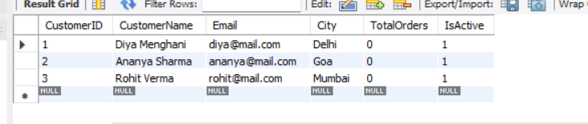

1. Updating Total Orders placed by Customers through Procedure 3(UpdateTotalOrders).

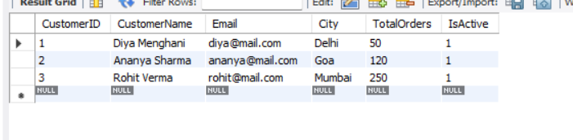

1. Counting Customers in a City(Delhi) through Procedure 4(CountCustomerByCity) using OUT Parameter.

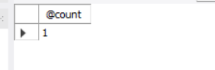

1. Inserting Unique Customers if Email doesn’t exist through Procedure 5(AddUniqueCustomer) using IF condition.

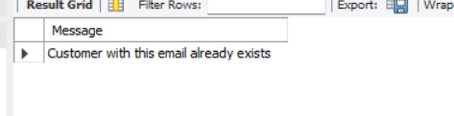

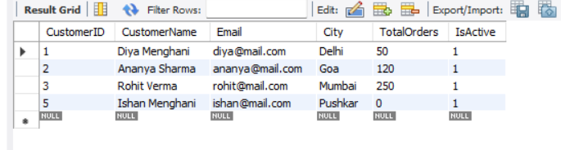

1. Getting a customer's loyalty status (Platinum, Gold, Silver, Bronze) based on their TotalOrders through Procedure 6(GetLoyaltyStatus) using CASE Statement.

-loyalty status of CustomerId = 1

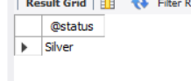

-loyalty status of CustomerId = 4

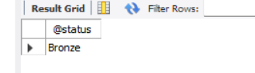

1. Calculating Final Discounted Price using Function 1(GetDiscountedPrice).

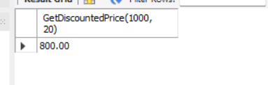

1. Calculating Offer Price based on Total Orders of Customers in Customers Table using Function 1(GetDiscountedPrice).

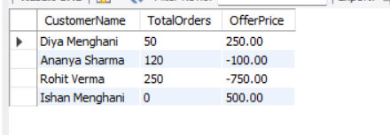

1. Calculating a normalized engagement score for each customer based on TotalOrders and whether the customer is Active using Function 2(CustomerEngagementScore).

